# “COSSY AIR-CONDITIONERS”

# “Dawlance”

**“Models”**

**“Dawlance Inspire Plus”**

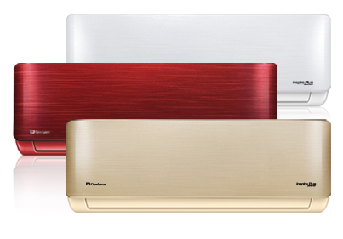

**Product Highlights**

* Inverter technology- saves upto Rs 26,000
* Say goodbye to stabilizers
* Dual function –cooling & heating
* Operates at a voltage as low as 155V

**“Specifications”**

**Capacity ~** 1 Ton

**Room Size ~** Min 125sqft - Maz 150sqft

**Colors ~** Maroon | Golden

**RS ~ 43,500.**

**“Dawlance Energy Saver 15”**

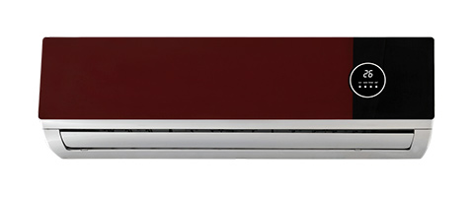

### Key Features

* Energy Saver technology-saves upto Rs. 4000 per year
* Fashionable design to match your interior
* Sleep mode function- for comfortable sleep
* Auto restart function

### Specifications

**Cooling Capacity ~** 18000 BTU ( 1.5 Ton )

**Room Size ~** 140sqft - 225sqft

**RS ~ 32,500.**

**“Dawlance Energy Saver 30”**

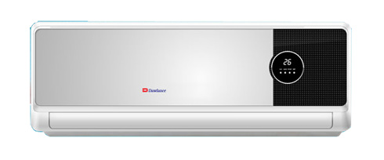

### Key Features

* Energy Saver technology-saves upto Rs. 4000 per year
* Fashionable design to match your interior
* Sleep mode function- for comfortable sleep
* Auto restart function

### Specifications

**Cooling Capacity ~** 18000 BTU ( 1.5 Ton )

**Room Size ~** 140sqft - 225sqft

**RS ~ 42,500.**

**“Dawlance Signature 15”**

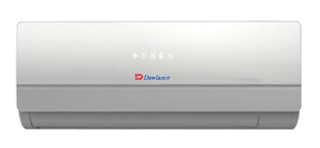

### FEATURES

* Elegant Design with Hidden Display
* Anti Rust condenser
* 3 mode operation: sleep mode, soft dry operation mode, cool mode
* Auto restart function

### Specifications

**Cooling Capacity ~** 12000 BTU ( 1 Ton )

**Room Size ~** 125sqft - 150sqft

**RS ~ 33,500.**

**“Dawlance Inverter-30”**

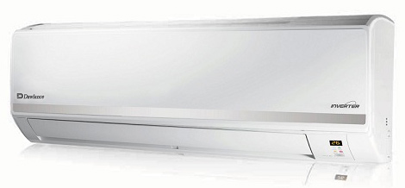

### FEATURES

* Inverter technology- saves 30% energy
* R 400A Refrigerant - provides faster cooling
* Dual function –cooling & heating
* Digital Protection device- protects AC from voltage fluctuation (180V-250V)

### Specifications

**Cooling Capacity ~** 18000 BTU ( 1.5 Ton )

**Minimum room Size ~** 140sqft

**RS ~ 78,900.**

**“Dawlance Monogram SL-45”**

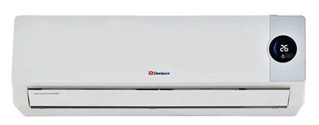

### FEATURES

* Higher air velocity & greater air flow
* High quality Auto Cleaning
* Wide angle swing

### Specifications

**Cooling Capacity ~** 24000 BTU ( 2 Ton )

**Minimum room Size ~** 210sqft

**RS ~ 58,000.**